# A Decent Proposal

*notes: ~9000 words (without references)*

## Introduction

In this thesis, I will develop and experiment within an aesthetic of ‘contemplative play,’ a play with the potential to more clearly show the nature of the world around us, and who we are within that world. The functionality of play, the nimble maneuvering of people together within a system, is a unique form of meaning-making that, in an age of fractured attention and instrumentalized leisure, offers a compelling alternative: a space of purposeless engagement where we encounter ourselves, others, and the world afresh. Where many games try to guide the player through specified challenges and defined narratives, contemplative play points the player toward an openness that provides the opportunity for introspection at a deeper, more ambiguous level. And this new potential of playful contemplation offers an antidote to many of the ways that people feel ill-at-ease with modern life.

Contemporary society has created a situation in which people feel overwhelmed, with fractured attention and the pressure to be continually active and productive. Many academics and artists have begun to push back on the narrative that a life is just a series of quantifiable achievements. Jenny O’Dell is a key voice in this movement, publishing books such as *How to do Nothing* %% cite %% and *Saving Time* %% cite %%, but many others have noted the pull to have a more meaningful relationship with the world than what the design of our technologies seems to dictate. We act and act, without giving ourselves time to reflect, to contemplate the nature of the world. In the past, art fulfilled this purpose. The paintings in our museums, the music in our recital halls, and the stories in our literature would give us opportunities for contemplation, but now even our leisure time is full of activity and over-stimulation. Philosopher Byung-Chul Han laments this loss of respite, saying “‘Leisure time’ lacks both intensity of life and contemplation. It is a time that we kill so as not to get bored. It is not *free, living time*; it is *dead time*.” (Han and Steuer 2023) %% [ M: We’ll see how this works ] %% In contrast, he claims “we owe true happiness to the useless and purposeless, to what is intentionally convoluted, what is unproductive, indirect, exuberant, superfluous, to beautiful forms and gestures that have no use and serve no purpose.” %% cite %% He names this concept “ceremonious inactivity” where “we do something, but to no end,’ resulting in the discovery of a reality that”reveals itself only to contemplative attention.” %% cite %%

Play is an ideal vehicle for this ‘ceremonious inactivity.’ It is a powerful and increasingly common way to engage with the world around us. For decades, game designers and researchers have claimed that play provides an opportunity to understand fundamental aspects of human existence. Bernie De Koven, a foundational figure in this movement, speaks to how play can elicit “a shared transcendence of personal limitations, of our understanding of our capabilities; a sudden, momentary transformation of our awareness of the connections between ourselves, each other, and the world we find each other in.” %% cite %% Similarly, in his book *Play Matters*, Miguel Sicart states that “[t]o play is to be in the world. Playing is a form of understanding what surrounds us and who we are, and a way of engaging with others. Play is a mode of being human.” %% cite %% Designer/researcher Frank Lantz argues that the very nature of play as being outside normal life contributes to its aesthetic value: “It is this distance that gives aesthetic experiences their power to be *about* life, its purpose and values.” %% cite %%

This aesthetic understanding of play provides a helpful framework with which to analyze the experience. In his book *Design Aesthetics,* Mads Nygaard Folkmann states that “aesthetics gives way for a reflection of how we perceive, sense, and are present in the world – that is, how we relate to our surroundings.” %% cite %% Common understanding of aesthetics can be slippery, with definitions stretching back to Plato and Kant and covering concepts such as phenomenology, art-for-art’s-sake, and epistemology. However, taking from Yuriko Saito’s concept of ‘everyday aesthetics’, which encompasses “the sensuous and/or design qualities of any object, phenomenon, or activity,” %% cite %% we can better develop a functional scaffold with which to approach the design and analysis of both play and contemplative experience. Game designers and researchers have put a lot of time and effort into developing a whole host of frameworks of the foundational building blocks of games, but an aesthetic understanding of play helps us to take a wider look. From this expanded perspective we can look at particular lenses of aesthetic engagement and how they contribute to the play as experienced by the player. With this expanded scope, and leaning on an aesthetic structure that I often think about in my own design practice, I propose looking at four distinct components of play: Player(s), Playthings, Playgrounds, and Playtime. These aesthetic pillars will give us helpful vantage points from which to think about how play intersects with the contemplative mode.

Contemplative play offers a way of engagement that is both reflective and participatory - an approach to dwell with and on the world and its inhabitants in a playful manner. The aesthetic lenses of Players, Playthings, Playgrounds, and Playtime will provide a framework to analyze the various ways and environments that make play ‘contemplative.’ For each aesthetic pillar, I propose to read related work and build out playful experiments in response to these ideas. In addition, I will position this work in communication with other artistic practices that encourage a contemplative engagement with the world along similar aesthetic spheres—such as soundwalks, deep listening, performative objects, contemplative architecture, and ambient media. Through this reflective design practice - making playful experiments in response to each of these aesthetic elements, reflecting on the nature of play experienced through these explorations, and leveraging the method for design materialization (MDM) for more profound insights - we will gain more crystallized knowledge about that potential, and develop ways to cultivate more engaging and meaningful play experiences.

## Background

### Reflective Design

In his 1982 book *The Reflective Practitioner*, Donald Schön sets up his argument for “reflection-in-action,” %% cite %% a way of thinking about design practice that has been adopted by academics and practitioners alike (Frayling, Redström, Eklund et. al, etc) %% cite %%. Though this design process-focused understanding of “reflective practice” is perhaps most commonly discussed with a focus on the designers themselves, we can also think about how as designers we can build “reflective practices” in to our designs. %% [P: Oh that’s quite nice. Did I miss this previously? Seems like an intriguing avenue to follow, has anyone done this before?] %% %% [M: Not in games maybe? But definitely if we look at Sengers, Performative Objects, etc] %%

The concept of reflection has found a strong foothold in the academic world, where it becomes a desired state for learners. Numerous thinkers and educators have relied on Dewey’s concept of ‘reflective thought’ as a goal for teaching. %% cite %% Dewey explains this state as “active, persistent, and careful consideration of any belief or supposed form of knowledge.” %% cite %% Dewey and those who follow focus on how reflection helps the learner learn. For them, the goal is the gaining of knowledge. Jennifer Moon, for instance, states that reflection is “a mental process of thinking about what we have done, learned, and experienced.” %% cite %% This understanding of reflection is unambiguous and practical, something to be harnessed for a desired end outcome.

Similarly, in their paper “Reflective Design,” Phoebe Sengers et al., %% cite %% build on critical theory to argue for designs that brings “unconscious aspects of experience to conscious awareness, thereby making them available for conscious choice.” %% cite %% Specifically, they “expand on reflection-in-action by not waiting for surprise to occur but by intervening to create or stimulate these reflection triggers.” %% cite %% This shifts the focus of reflection away from the nature of the designed object and instead places it on the nature of technology as a whole. Sengers et al. argue that by focusing on the user’s critical reflection, designers are able to counter norms and create positive social effect.

However, there is also an opportunity for designing more ambiguous reflective experiences. One possibility is through experimental interactions. Lars Hallnäs and Johan Redström’s %% cite %% “Slow Technology - Designing For Reflection” introduces the concept of “slow technology […] as a tool for making reflection inherent in design expression.” %% cite %% They propose that slowing down, removing clarity, and building friction into designs can make the user reflect on the nature and role of technology in their life. A doorbell that influences several fans behind an array of fabric squares communicates something different from the usual chime, but what exactly? The user is left to consider these objects and interactions and what they might mean. This is similar to Rilla Khaled’s proposal of a ‘reflective game design,’ where the designer designs to highlight questions over answers, disruption over comfort, and reflection over immersion. %% cite %% These types of games are designed in stark contrast to serious games, which often have an underlying lesson to be learned. Rather, reflective game design is a space where “asking meaningful questions is more important than providing clear answers.” %% cite %% ### Contemplative Design

In order to differentiate the present work from the widespread use of ‘reflective design’ as a means for targeted critical reflection, I propose the term *contemplative design*. The word contemplation stems from the latin *com* + *templum*, and was originally “to mark out a space for observation.” %% cite %% . From this tradition, translators rendered the earlier Greek term *theōría*, used by both Plato and Aristotle, into the Latin *contemplatio*, which gets used in both the Platonic contemplation of eternal Forms and the Aristotelian notion of contemplation as the highest form of human happiness. %% cite %% Later, the term took on a more religious and spiritual tone, especially popularized by the twentieth century Trappist monk, Thomas Merton, and his book “Seeds of Contemplation.” %% cite %% More recently, scholars such as Byung-Chul Han %% cite%% and Oludamini Ogunnaike %% cite %%, have expanded the idea of contemplation into a more mysterious interplay between humans and the world. This use of ‘contemplation’ gets more to the root of what a deep interaction with designed experiences could feel like. In their paper “Contemplative Neuroaesthetics and Architecture: A Sensorimotor Exploration,” Djebbara et al. %% cite %% use the term to indicate “heightened level of awareness and an intentional focus on the present moment, fostering a state of deep reflection and non-judgmental engagement.” %% cite %% Using examples from architecture, including the Rundetårn in Copenhagen, Denmark, Louis Kahn’s Salk Institue in La Jolla, California, and the Chartres Cathedral in France, Djebbara et al. argue that these buildings can bring about states of deep contemplation/reflection in a viewer by “enforcing an embodied experience of presence. %% cite %% Indeed an entire field of contemplative architecture has developed that explores how architectural spaces of all kinds can foster these kinds of deeper experiences. %% cite %%

We see this focus on contemplative design in other places as well. Such designs are often art objects, with critical design and speculative design as example approaches. Anthony Dunne’s Faraday Chair, for example, uses a large Faraday cage to create a haven from electromagnetic fields, which causes the viewer to ask, “If the inside is empty, what is outside?” %% cite %% Additionally, the “chair” is actually a daybed, which Faraday claims contributes to the notion that “once electromagnetic fields are taken into consideration, conventional assumptions about everyday objects need to be reexamined.” %% cite %%. In Critical Play, Mary Flanagan calls these the designs that “represent one or more questions about aspects of human life.” %% cite %% This ‘critical play’ is a type of play that pokes at the very nature of play itself (rules, competition, playspaces, for example) and uses that questioning stance to reflect on the world at large.

Soundwalking is another field of artistic practice related to my understanding of contemplative design. Soundwalking started as part of R. Murray Schafer’s *World Soundscape Project*, %% cite %% which arose from active listening practices developed by artists like John Cage and Pauline Oliveros. %% cite %% Schafer and those in the project sought to anchor these active listening practices to a given place. Hildegard Westerkamp especially believed that through soundwalking, listeners could better understand their sonic environments. %% cite %%

Janet Cardiff and George Bures Miller use their recorded soundwalks to guide the listener through a world of their making, a sonic world that is overlaid onto a real, physical place. %% cite %% In *Her Long Black Hair*, as the listener walk through Central Park in New York City, snippets of conversation slip by that feel like they are in the same space as you. Cardiff speaks directly to you but then has a conversation with others who are not visibly present. Recorded audio effects of long-gone marching bands, sirens, and political rallies make the listener feel like they are experiencing a highly professional radio drama, creating a space for deep and truly unique contemplative experiences where “our seemingly dull everyday existence has the potential to reveal simultaneous magical worlds of experience.” %% cite %% (24) %% [ P: Might you get push-back on whether or why this leads to contemplation? Currently this is more an assertion… ] %% %% [M: Maybe? I sure felt very contemplative at certain points] %%

Kristina Niedderer’s “performative objects” are another noteworthy example. %% cite %% She distinguishes these objects from Jacques Carelman’s *Catalogue d’Objets Introuvables* %% cite %% by describing them as, “objects that can cause mindfulness in the context of everyday use, and not in the institutional context of art.” %% cite %% This separation means that the performative object must rely on adaptations within its formal elements to create a contemplative state *while remaining functional.* This is particularly interesting as we consider designing contemplative experiences for game-like experiments that retain their sense of play. %% [ P: I like the thing here of specifically identifying something you’ll want to return to, worth keeping an eye out for which other theorists contribute something like this and consider whether it ought to be highlighted further structurally ] %%

Another reference point for contemplative design is “ambient interactive experiences.” %% cite %% These designs build on ideas from other slow, ambient media such as the music of Brian Eno %% e.g. %% and the films of Godfrey Reggio %% e.g. %% to create a more passive yet potentially deeper experience. The field of slow games is a compelling and clear precedent for this, but thinking about ambient media opens up the opportunity to include a lot more material. These projects are interested in slow pacing, obfuscation, and less “comfortable” experiences, with varying degrees of success. Game designer and researcher Tracy Fullerton refers to this as ‘reflective play’ where slowness isn’t “equivalent to meaningfulness, but rather because the process of making meaning through reflection requires time at a human pace, takes cycles of response, interpretation, and unpacking of experience.” %% cite %% Examples include the cooperative game *Journey* %% cite %%, the work of David O’Reilly %% cite %% and Pippin Barr’s *v r 5* %% cite %%, among others. ### Design Aesthetics

There are various existing frameworks for thinking about the elements of play that might be relevant for a study of contemplation. While these frameworks are often overly descriptive, there are elements withing that can inform our current study, providing a solid foundation for our exploration.

Salen and Zimmerman, in their book Rules of Play %% cite %%, set up an understanding of meaningful play. In their definition, this relates more to how the playful systems in a game relate meaning back to the game itself. However, this could be expanded to how play could broaden our understanding of meaning-making in the world. In A Game Design Vocabulary %% cite %%, Anna Anthropy and Naomi Clark call this the context of a game, discussing specifically how the design aspects of a digital game (camera, character, sound, etc) communicate aspects of the game to the player. Could we leverage the contexts of play, pointing outward to contemplate on life in general? What are the specific contexts that we could use to do so?

In *The Art of Game Design: A Book of Lenses* %% cite %%, Jesse Schell introduces the concept of lenses that we can use to develop and evaluate games from specific vantage points. While it may be overkill to apply each of his 113 lenses to our study, applying this concept of lenses as a way to establish and evaluate context is a valuable exercise. Hunicke et al.’s “MDA: A Formal Approach to Game Design and Game Research” identifies three key components for game design: Mechanics, Dynamics, and Aesthetics. Their concept of *aesthetics* as “the desirable emotional responses evoked in the player, when she interacts with the game system” %% cite %% is a good starting place, but is a slightly different understanding from mainstream design aesthetics, where as Folkmann explains, at a broader level it “offers concepts for investigating and understanding how design is constituted, how it appeals to and affects people, and how it frames human experiencing.” %% cite %%

Thinking of the context of play, specifically through these wider lenses of design aesthetics, is an excellent framework with which to explore how play could engender contemplative experience. ### Aesthetics of Contemplative Play

Book III of Schopenhauer’s %% cite %% “The World as Will and Representation” holds some key language about what he calls “aesthetic contemplation,” which is pertinent to the ideas of contemplation in artistic fields. In section 34, he describes the shift from looking at something through ‘reason’ to “a steady contemplation” by saying:

if, instead of all this, we devote the entire power of our mind to intuition and immerse ourselves in this entirely, letting the whole of consciousness be filled with peaceful contemplation of the natural object that is directly present, a landscape, a tree, a cliff, a building, or whatever it might be, and, according to a suggestive figure of speech, we *lose* ourselves in this object completely, i.e we forget our individuality, our will, and continue to exist only as pure subject, the clear mirror of the object

%% cite %%

This concept of aesthetic contemplation helps to specify the type of aesthetic play experience that one could have, an experience that moves from the surface to something deeper. What is especially helpful is how Schopenhauer includes space for *active* contemplation on the viewer’s part. It is not a passive, peaceful, zen calm, but rather an attitude of looking that is searching for more. Some philosophers and art historians have coined the term [“aesthetic attitude”](https://iep.utm.edu/aesthetic-attitude/) to explain this idea. %% cite %%.

Combining this with an *aesthetics of play*, we can create a series of lenses with which to explore the idea of contemplation. I find that Katja Kwastek’s %% cite %% *Aesthetics of Interaction in Digital Art* is foundational here (and even includes a chapter on the “Aesthetics of Play”). In my personal practice, I often think of four big picture aspects of play. First, the players are those who willingly engage with the playful systems. Second, the playthings are the trappings of games, the objects with which the player interacts. Third, the playspace is the boundary created by play, a boundary that is often as much mental as physical. Lastly, playtime is the time set aside and made ‘sacred’ by the play, a time that expands and contracts to contain more than the sum of its seconds. These four aesthetic lenses, when used as a way to reflect on play, will give us a way to in to the discussion, a way towards the construction of unique experiences with contemplation in and through play.

## Methodology

This research relies on game experiments to examine the possibilities in manipulating playful aesthetics towards contemplative ends. These playful experiments will be tangible outputs to explore ideas found in the overlap between playful aesthetics and contemplative design, with knowledge arising both from the active building of these experiments as well as in conversation with other designers. Each of these prototypes will go through a series of stages. The overall trajectory for this exploration will resemble the classic design process, with stages of divergence and convergence throughout. As in the traditional interactive design process, each stage of the process is evaluated in stasis by me and in conversation with design peers. These conversations will lead to new insights and feed into future iterations of the overall concepts. %% [ P: Hmm. It’s quite stiff. I’ll think further. ] %%

Throughout this exploration, I will initially use an internal iterative design process as a basis from which to pursue and evaluate my designs. This is in alignment with ideas stemming from traditional iterative design practice where designers rapidly develop and test many ideas on an individual level, discarding anything that obviously doesn’t work, and refining all of the ideas down to a few testable prototypes. %% Iterate? %% This method also relies on the design through research practices as proposed by Frayling and Redström, in which knowledge is gained through the practice of design. %% cite %%

Additionally, I will gain knowledge about my solution through observation and conversations with other designers. Sharing work with other designers who have deep experience in a discipline is a great way to catch these early mistaken assumptions that I might be making about my audience, goals, and proposed solutions. %% [P: Probably needs to be deeper and more grounded to sound like it properly belongs in a PhD, which I believe it does.] %%

### Foundations: Research Through Design, Design Practice, and Practice-Based Research

In his paper for the first issue of Research in Art and Design, Christopher Frayling introduced his ideas for the relationship between research and design. %% cite %% He distinguished between research into art and design (where the research is historical, cultural or theoretical), research through art and design (where the research is into the processes and tools for future design methodologies), and research for art and design (where the end product is an artifact). In the years following, many researchers adapted these ideas, and the area that Frayling labeled as research for art and design has become more widely understood as research through design.

In their introduction to Perspectives on Design Research, Bærenholdt et al. %% cite %% refer to this mode as both research through design and design-based research (including design through research) noting that, “design becomes as much a medium and process of research, as a result.” %% cite %% It is through the making of designs that knowledge is gained, but how we exactly understand this relationship can be more complex.

The specific framework that I employ to understand how my research and designs are in conversation is firmly situated in Johann Redström’s tactic of Sequencing.%% cite %% Redström expands on Frayling’s concept of research through design and explores explicit tactics for how these methods are employed. His concept of sequencing, where design and theories are meant to coexist throughout the process, is of particular interest. “Using a highly iterative process, more developed relations between theory and design can evolve as the understanding of how the different design variables will have an impact on the test situation grows deeper.” %% cite %%

~~I believe that t~~ The iterative design process is uniquely suited and positioned to benefit from this concept of sequencing. As a designer, it is fundamental that you document and reflect on your designs and how they are being perceived by a given audience. In this way, you are in constant conversation with the design, testing its validity, and gaining knowledge in the process. %% [P: Very Schön-y too] %%

This understanding of the benefits of the design process is echoed in the concepts of practice-based research. Linda Candy, in the Routledge International Handbook of Practice-Based Research, defines practice-based research as “a principled approach to research by means of practice, in which the research and the practice operate as interdependent and complementary processes leading to new and original forms of knowledge.” %% cite %% An important concept here is that it is through the creations of these designed artifacts that the researcher is able to test and gain knowledge about the world.

### Internal Iterative Game Design Process with the Method for Design Materialization

The initial stages for this research will rely on my practice as a game and sound designer. It is here where the most radical idea generation, prototyping, reflection, and refinement will happen.

In *The Reflective Practitioner*, Donald Schön argues that “research is an activity of practitioners. It is triggered by features of the practice situation, undertaken on the spot, and immediately linked to action.” %% cite %% I have found that this very accurately describes my own game design process. As a designer, I am in a dialog with my design, and the process involves thousands of decisions that are repeatedly implemented and evaluated, with this interchange happening throughout the entirety of the process.

In my practice, this process starts with a sketching phase. %% cite Buxton? %% Ideas about visual style, game mechanics, themes, etc are explored by rapidly sketching and reflecting on their feasibility and design potential. The goal of this stage is to generate as many ideas as possible, helping me think through the problem and generate possible solutions. These ideas are then refined down to something more concrete and actionable that I intend to build and test in the digital space. The collateral from these sessions are captured using a camera to be included in any online documentation.

Once the design process moves into the digital space, I use the game engine Unity, image creation software Photoshop, and digital audio workstations (DAWs) like Reaper and Ableton Live in conjunction to build prototypes that implement some of the most promising ideas from the ideation phase. As these prototypes are built, new ideas emerge and those that do not work as intended are discarded. %% Maybe explicitly point out the conversation with materials taking place here %% This refinement happens repeatedly and at a very quick pace. Then, once the ideas are more solidly understood, the process of refinement introduces even quicker but far less radical incremental changes. This stage adheres to Jesse Schell’s Rule of the Loop, where “the more times you test and improve your design, the better your game will be.” %% cite %%

Through all of these phases, I implement the Method for Design Materialization (MDM) first presented by Rilla Khaled, Jonathan Lessard, and Pippin Barr %% cite %% in “Documenting Trajectories in Design Space: a Methodology for Applied Game Design Research.” In this method, the small decisions that a designer makes during the course of their process are documented using the version control system Git %% [ P: GitHub is just the cloud storage platform in the end really ] %%. Any time that the designer uploads a commit, they write a detailed message commenting on the particular design decision, motivations, thoughts, and any future plans at that specific moment in time %% [ P: And sticking with Schön, reflections of conversations with material, relationship to technical practice to design ] %%. This then becomes part of the overall archiving not only of a design’s trajectory, but also the designer’s unique thought process. Khaled et al. %% cite %% state that the “history of commits over time can give an understanding of the overall design space and how it has been traversed: its pressure points, its branching points, where decisions have been made, and where possible lines of inquiry have been pruned.” %% cite %% The most important thing about this is that the large amount of qualitative data produced makes it possible to use methods of analysis derived from grounded theory %% [ P: and thematic analysis, and CITE ] %% to organize, analyze, and develop theories about the information that is generated. From this analysis, patterns can emerge to aid in reflection on the solutions and suggest new possible directions for exploration. %% [ P: Going to want to expand on the analysis component here and get explicit about the procedures. ] %%

The end goal of all of this should be a playable prototype that has made it through several phases of internal testing and refinement and is ready to be shown to others. %% [P: Really, though, as per the above, the end goal is a prototype *and the archive of design documentation*] %% Generally, I rely on my network of trusted colleagues and friends for feedback on the work that I am making. These are other game and/or sound designers and those whose opinion I can rely on to give me valuable feedback. This sharing of work often sparks a dialogue that helps me refine both the thing that I am making as well as the entire thought around the conceptual side of the work. %% [P: Should probably think of a way to formalize this a teeny bit, there’s probably some official methodological approach that describes this] %%

This entire phase of the process will take place within the framework of the MDM. All feedback will be documented and added to the project repository %% [P: Think this is the first mention of a repository? Need to check in on technical language and make sure it’s always glossed on first use] %%. This way it can be included in the overall analysis of the design research. This synthesized information will then be applied to further iterations on both this particular design solution and future explorations. %% [P: I think you’re saying that even the analysis process is in the repo? May needed to be clearer] %%

### Summary

In summary, my methodology for each iteration of this research will go through a series of phases. Firstly through rapid prototyping on an individual level, where my intuition %% [P: And experience and… probably want to sell yourself as experienced and already good at this] %% as a designer will help to refine an initially large amount of ideas to only those with the most potential. This design through research practice will facilitate knowledge creation both about ==the problem and these possible solutions== %% [P: Bit vague] %%. Additionally, I will leverage observations and conversations with other designers to test these designs, quickly implementing what is learned into a series of final playable prototypes that will arise from the study that I am undertaking in each of these aesthetic lenses. During the entirety of the design process, I will be using the method for design materialization to document, track, and analyze both my individual designs and the overall process to see what new knowledge can be gained and what new solutions might arise.

## Timetable

In general, I propose to focus on each of the four main aesthetic-topic areas for a set duration. During this focused time, I will read literature and experience first-hand the art and design experiences in this domain, responding to the material both in writing/reflecting and creating playful exploration prototypes. Once the initial stages have been complete, I will spend the remaining time on the synthesis and writing of the thesis paper.

* Explorations
  + Player (Sep. 2025 - Dec. 2025)
  + Playthings (Jan. 2026 - April 2026)
  + Playgrounds (May 2026 - August 2026)
  + Playtime (Sep. 2026 - Dec. 2026)
  + Synthesis, Thesis Writing, and Revisions (Jan. 2027 - Dec. 2027) %% [P: Yep, fine by me. It’s potentially the case you don’t need the full year at the end, but why not right, and it’s strategic at some level anyway, so all good.] %% ## Chapter Breakdown

My initial idea here is to have each of the main chapters focus on an aesthetic of contemplative play. Through each of these lenses, I will look at a specific artistic practice from outside the realm of games and then apply the lessons learned to a designed play experience. %% [P: Feels like this can obviously be more confident and together. Not clear you need a Part 1 and a Part 2, I think it can just be a series of chapters] %%

### Part 1

- Introduction  
- Background  
- Methodology

%% [P: The boring standard approach would just be Introduction, Background, Method; if you want to go down that road.] %% ### Part 2: Aesthetics in Contemplative Play

%% [P: It’s not impossible you could be pinged a bit for these bits being a little on the short end. Feels like you probably already have so much more to say and project about the area + the project(s) you want to talk about.] %% #### Player

In this chapter I will:

It will include the following sections:

Aesthetic description Related genre description Existing crossover Ideas to explore

Much of play is performative. A player acts out scenarios. They move their body in a coordinated effort with other players or the playful system. Play can even be designed so that the act of playing is engaging from those outside of the playspace. Professional sports is a clear example of this, but Let’s Plays, E-Sports, and arcade experiences (kids gathered around a Street Fighter cabinet in the 90s or DDR machines in the early aughts) also point to the possibilities of “performing” play.

Soundwalking is an excellent genre precedent to think about how not only our physical bodies inhabit an experience, but also how the physical world around us allows for performance. Artists like Hildegard Westerkamp built on the active listening practices of Pauline Oliveros and John Cage to invite listeners to playfully explore acoustic space. Tapping on bridges, shouting in tunnels, banging on cans: these playful acts require the listener to become performer in order to discover something new about the world around them.

Thinking about the player as performer and how soundwalks (and other interactive artworks) have used the movement of participants to create meaning, what new contemplative and playful experiences can we create?

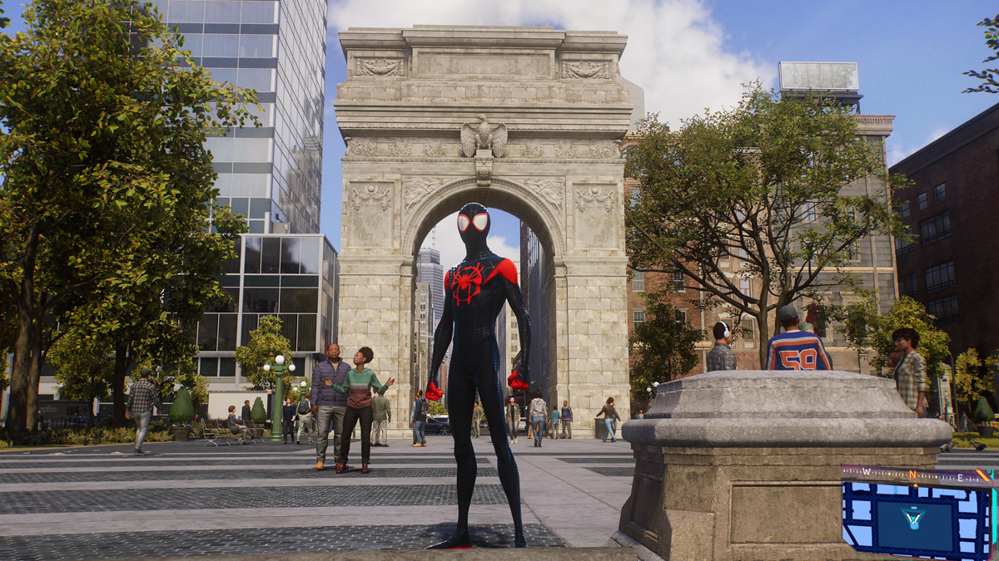

Miles Morales

Games and Soundwalks both operate in this area of “performance,” but come from at it at slightly different angles. The game “performance” is generally much more about how the avatar “performs” that the actual player. An early attempt to interweave soundwalks with play was a series of soundwalks for the PS5 game *Spiderman 2*, and while compelling for a variety of reasons, this concept of performance remains unexplored. %% cite the paper %%

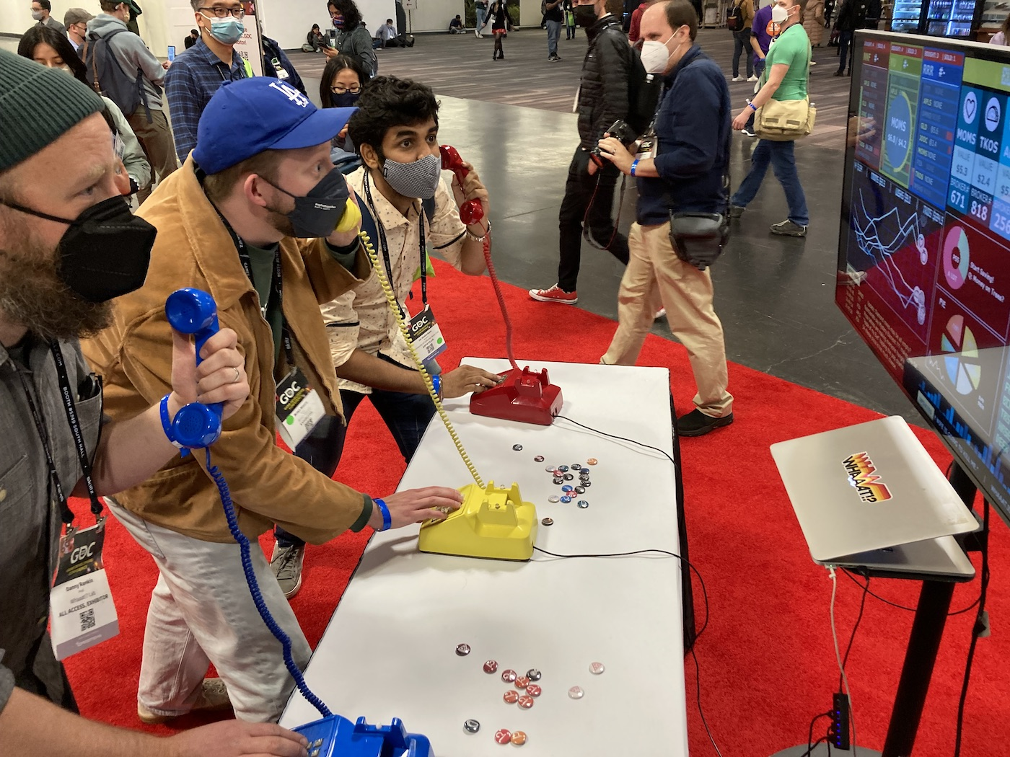

Buy! Sell!

Installation-based play, Like Buy! Sell! thinks about the player as performer. In a similar way, playful soundwalks could be a space to explore the overlap between play and performative spaces. Janet Cardiff hints at these playful moments in her soundwalks, and future work (such as the “An Invitation to Play” soundwalk accepted to ICMC 2025 in Boston) will be a further exploration of these ideas.

#### Playspace

Space is a core aesthetic to the play experience. The concept of the magic circle in particular, sets to explain the physical, and mental demarcation between “the real” world and the imaginatively playful world. It is this established structure that gives the player agency to engage in playful acts, choosing one possible action over another and reflecting on how those actions contribute to the imagined world.

Contemplative Architecture is similar in that the creation and consecration of a space can engender different perspectives than the ones a person came in with. Changes in sound, light, and material imbue the space with a meaning in contrast to the outside world. Huizinga’s discussion of the “play-festival-rite” is of particular interest here, as it provides a direct link between play and contemplative (even sacred) spaces.

Focusing on this concept of the space in which play happens (i.e the magic circle) and examples from Contemplative Architecture, how can we create playfully contemplative experiences? Busy Work and TIKATMOS are two games that explore this question by creating distinct (and physical) gameworlds to facilitate a certain level of engaged play.

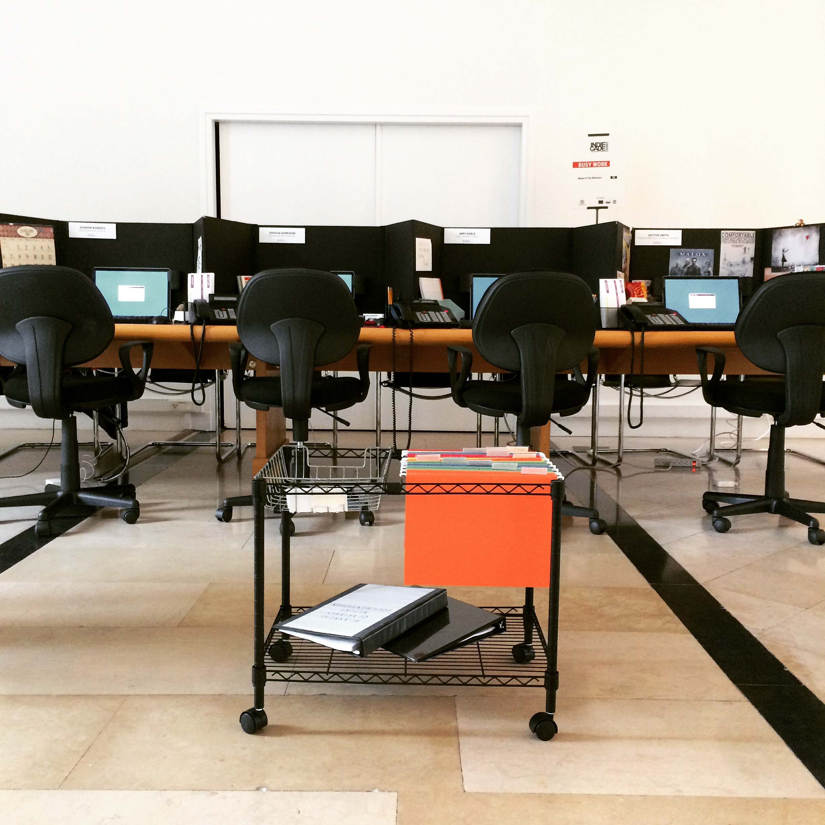

Busy Work

Using narrative elements, physical actions, and environmental storytelling through the built environment, Busy Work examines the modern challenge of accomplishing work while juggling conflicting priorities. Players are left wondering if what they do matters, whether or not they are set up to fail and if the rewards are worth the effort. People handle the mundane and possibly futile aspects of life in many ways, and this work helps player to reflect on this by giving them playful options based on lived experience.

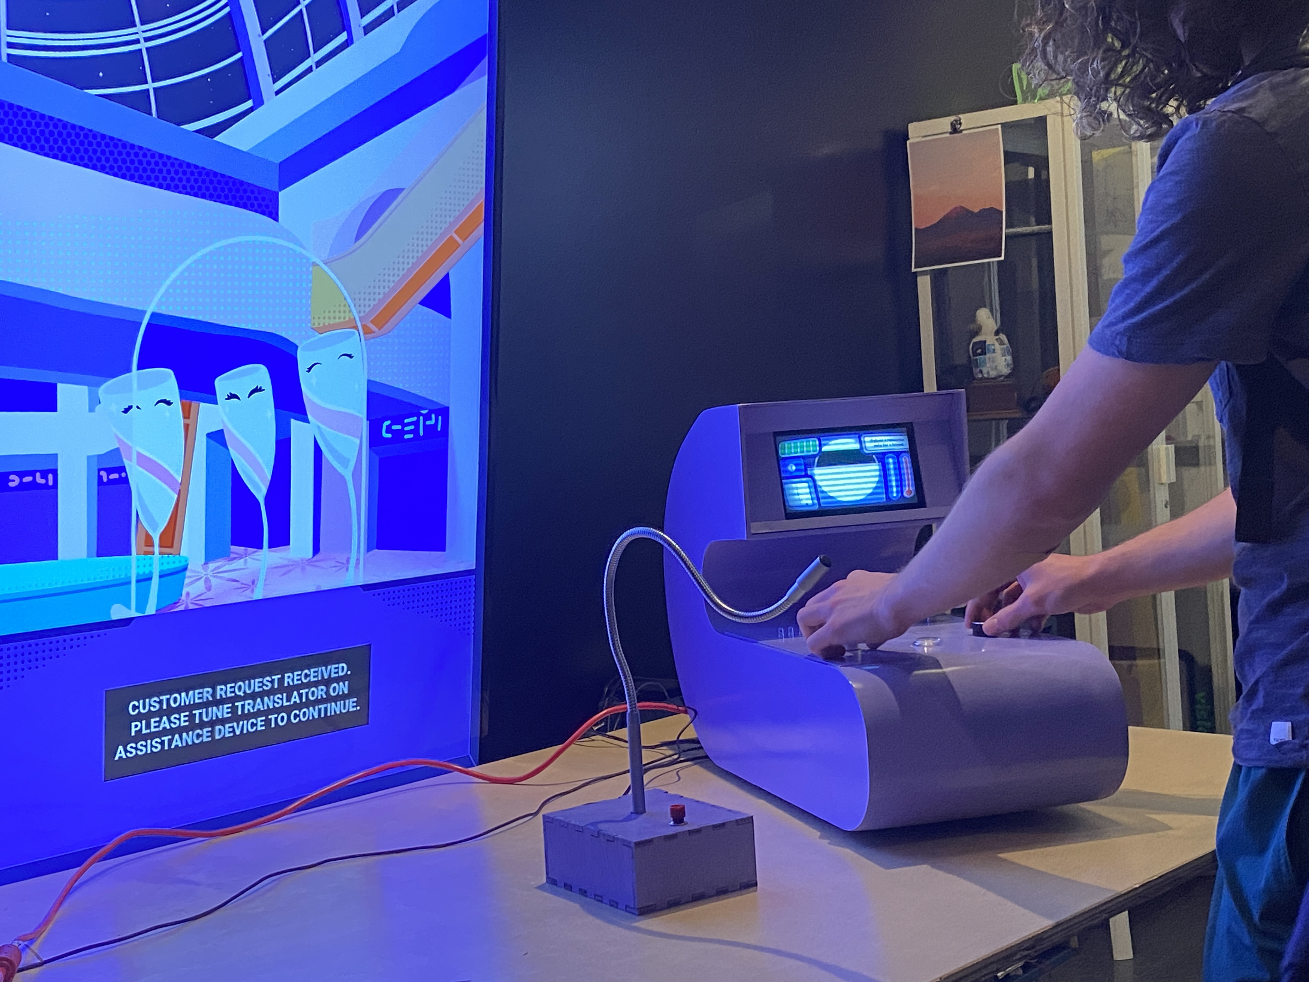

TIKATMOS

TIKATMOS is a deeply speculative interactive installation that seeks to explore gaps in conversation, sustainability, the future of humanity, and what it means to help using voice-control technology and adaptive audio. By putting the player in the role of an unidentified species, and creating a fleshed-out world space, TIKATMOS pokes around some interesting questions about identity.

#### Playthings

The materiality of the objects in play has a profound effect on the playful experience. Not only do textures, shapes, and other physical characteristic communicate essential aspects of these items (which Fullerton dubs “resources”), but the very introduction of external elements themselves communicates something about the playful experience. A verbal bang, pointed finger, plastic cap-gun, and hyper-realistic 3D modeled firearm say something of the values at play in the games that include them, but the presence of weaponry at all as a “resource” communicates even more.

The Performative Objects of Kristina Niedderer fit well into this understanding, as they strategically explore the material and functional aspects of objects in order to provoke what she calls “mindful interactions.” Their materiality (often at odds with rather than in service to their functionality) initiates a more reflective stance from the user within the context of their intended use. Yoko Ono’s “Play it by Heart” is another clear example of how the materiality of an object can be at service for both play and contemplation.

“Performative resources” seems then to be a fertile space for exploration (albeit not a great name). Within this understanding, a designer would create material objects for play in which their materiality informs both the playful act and the associated contemplative experience.

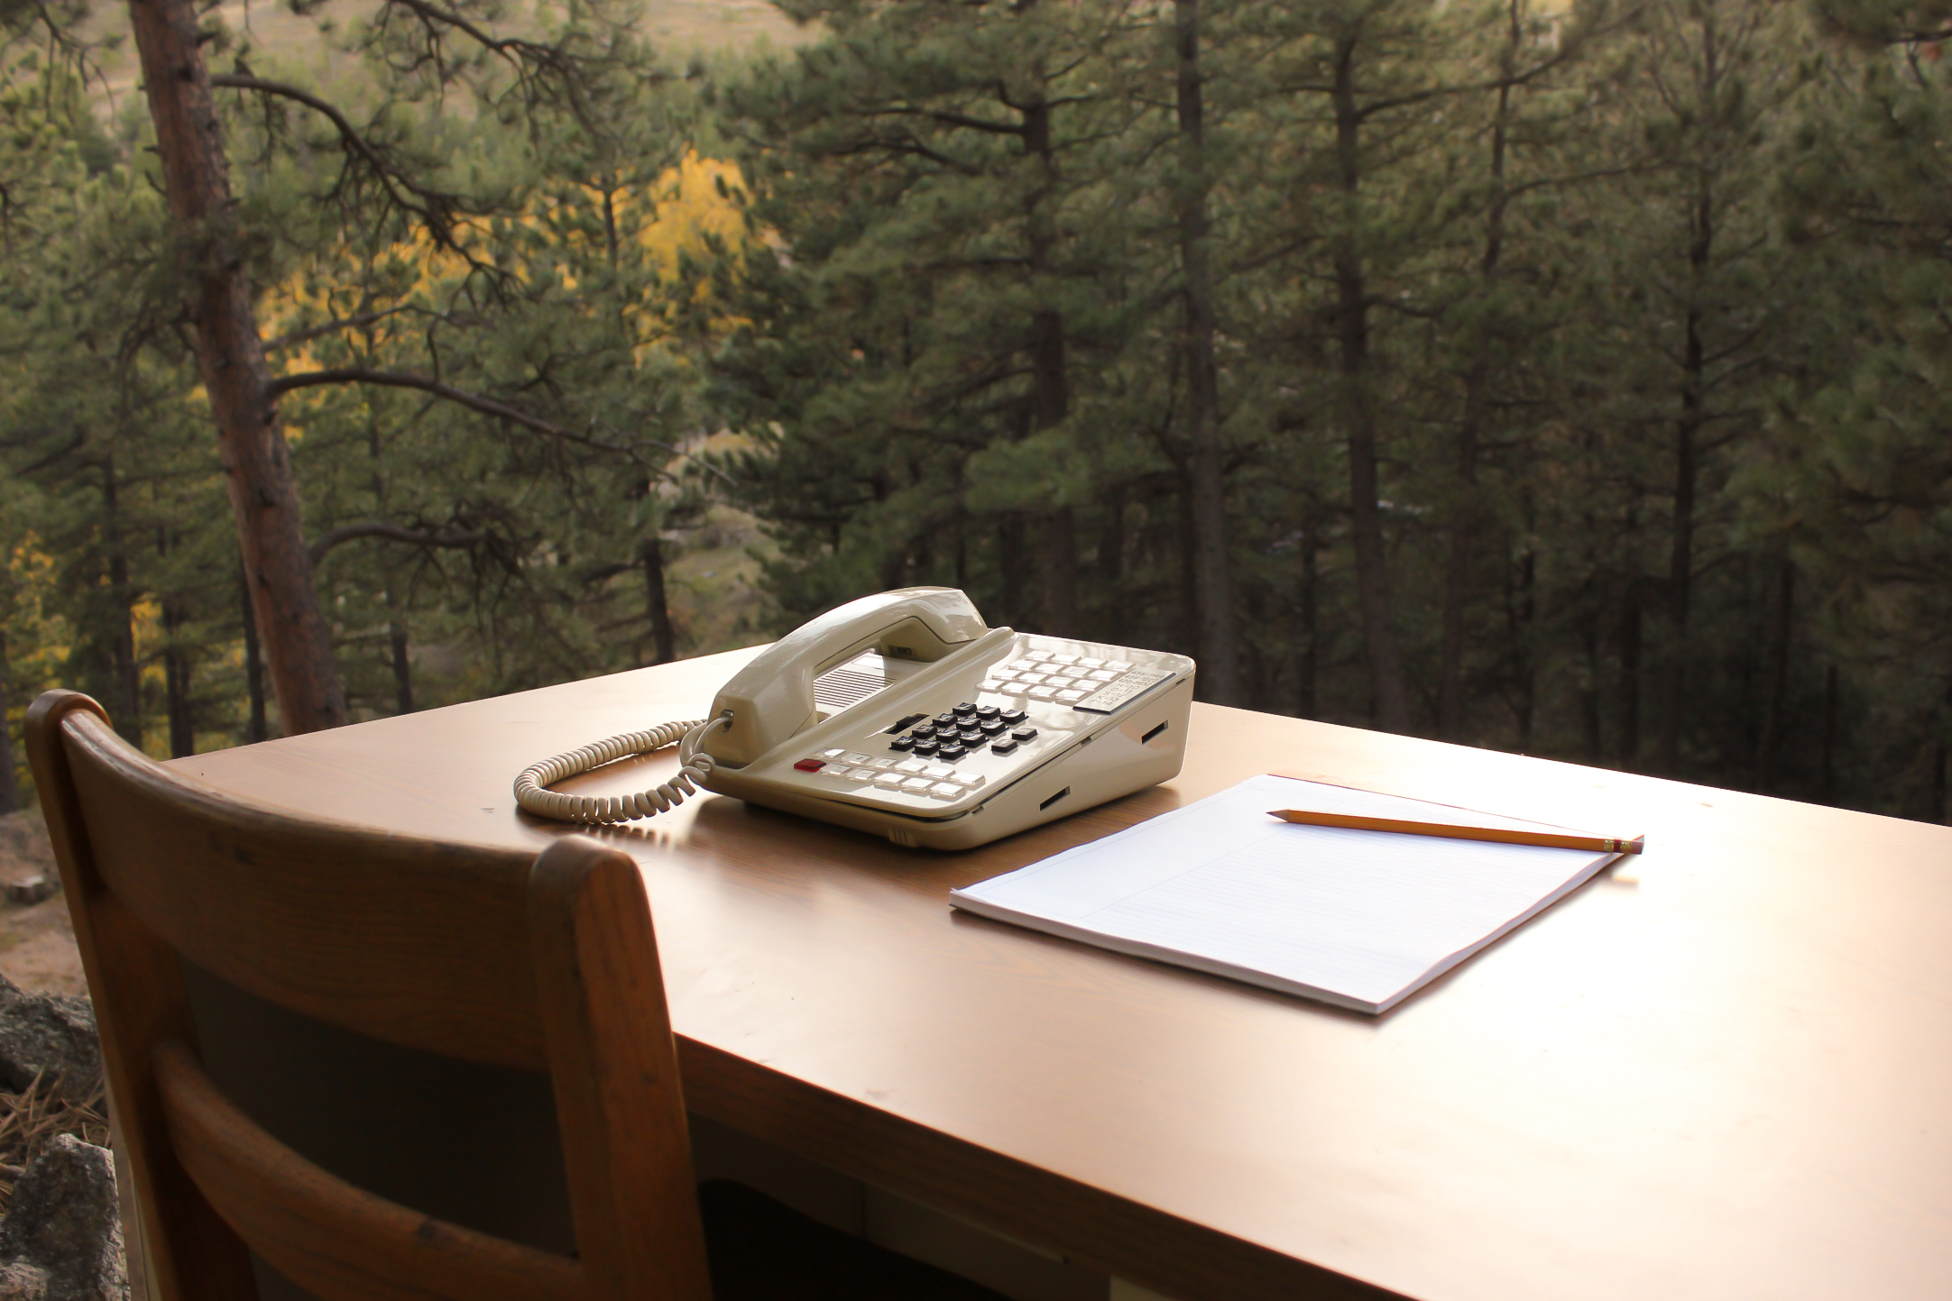

Please Hold

Alt-ctrl is specifically interested in an expansion of the “stuff” of games. We build alt-ctrl installations to ask, “what if a phone was a controller,” or “what if a series of hold menus could be playful?” Games like TIKATMOS, Busy Work, Buy Sell, and Please Hold (above) rely on their objects for the player to interact with. These objects communicate the game world, but they also can work in cooperation with (or opposition to) their perceived uses. A phone communicates “phone-ness” but does the playful experience hidden within become stronger by breaking free of its mundane appearance?

#### Playtime

In *Das Spiel. Theorien des Spiels*, Hans Scheuerl argues that “play is always a ‘playing between’” various characteristics like seriousness and pleasure, rules and chance, focused effort and ease. This concept of ‘ambivalence,’ in conjunction with Csikszentmihalyi’s ‘flow’ helps to explain the playful state. The oscillation between the states is where play exists. Salen and Zimmerman use the example of the ‘play’ in a steering wheel.

Ambient Media also relies on this tension between something that can demand focused attention but also exist entirely in the background. Eno imagined his ambient music as the soundscape to an environment, ever present, always playing, with the listener able to tune-in or out as they pleased. Games like Oreilly’s *Mountain* are examples of how ‘ambient games’ might function, in which the player’s attention can traverse this ambivalent space at will.

How can the concept of ambient ambivalence be leveraged in regards to time? How can we move the playing of games *away* from flow-focused and mark the passing of time for contemplative ends? Note: PB’s statement of “time is one of the most valuable resources that we ask of our players” is of particular note here.

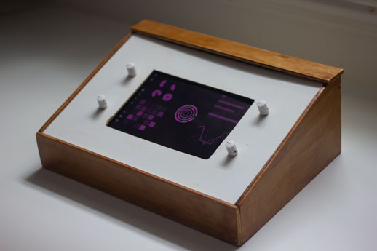

Lest Ten Horizons Cry

*Lest Ten Horizons Cry* is an exploration in how we can explore game spaces with traditional electronic instrument interfaces. In this way, the design of this experience is also deeply concerned with material object, but ths way that that interaction changes over time is the most relevant here. Initially, users are presented with a custom-built boutique synthesizer. By turning the dials, the various sonic parameters can be adjusted, creating an ever-evolving sonic landscape. The large synthesizer screen displays simple, cryptic, but generally traditional visuals mapped to each of these physical dials. It is only after focused attention from the player that another world can be discovered. And this attention is not required. Only a player who is willing to engage with a seemingly “difficult” interface is rewarded with this experience.

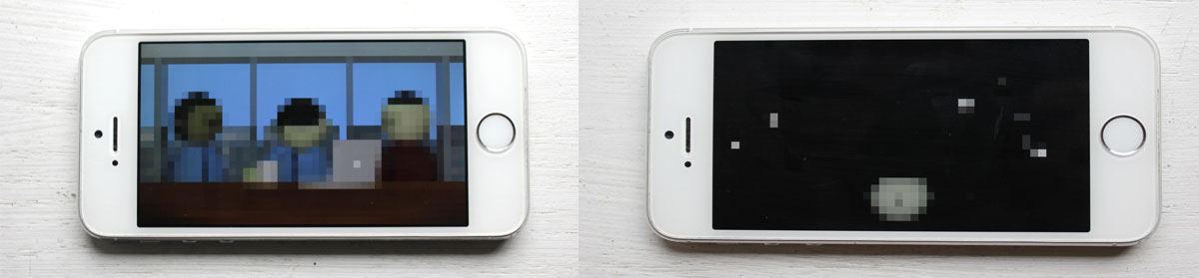

The Meeting

The Meeting functions on a similar concept. What looks on the surface like a standard “clicker game” becomes an entirely different experience if the user refuses to interact with it the way it seems to communicate that it should be interacted with (i.e to *not* touch it; to *not* click)

## References

Han, B. C., and D. Steuer. 2023. *Vita Contemplativa: In Praise of Inactivity*. Polity Press, 2023. <https://books.google.ca/books?id=edzeEAAAQBAJ>.